MICROLEND:COMPREHEN SIVE FINANCIAL MANAGEMENT APP

## *TEAM MEMBERS*

D Team Lead: Rachit Kumar

D Lead Developer: Kartikay Achint D UI/UX Designer: Gaurav Karakoti D Financial Advisor: Ridhi Gupta

## *ABSTRACT*

MicroLend is an innovative mobile application designed to empower entrepreneurs and small business owners by providing micro-lending, budget and expense tracking, and personalized financial advisory services. The app aims to simplify financial management for users, enabling them to make informed decisions, secure funding, and maintain sustainable growth. With features like real-time expense tracking, loan application management, and tailored financial insights, MicroLend addresses the challenges faced by entrepreneurs in accessing capital and managing finances effectively. The integration of Vultr’s cloud services will ensure scalability, reliability, and enhanced performance, facilitating a seamless user experience.

## *PROBLEM STATEMENT*

Entrepreneurs often face significant barriers in accessing financial resources, budgeting, and expense management. Many lack the tools to track their finances accurately and receive appropriate financial advice tailored to their specific needs. This leads to cash flow issues and ultimately stunts business growth.

## *PROPOSED SOLUTION*

* Micro-lending Platform: Facilitates small loans from various lenders, with a streamlined application process.
* Budget and Expense Tracker: Users can categorize expenses, set budgets, and track spending habits.
* Financial Advisory Services: Personalized recommendations based on user financial data and goals.
* User-friendly Interface: Simplified navigation and interactive dashboards for real-time financial tracking.

### USE OF VULTR SERVICES

 ***Scalable Hosting***: To manage varying loads of user traffic efficiently.

 ***Database Solutions***: Utilizing managed databases for secure and reliable data storage.

 ***Content Delivery Network (CDN):*** Ensuring fast content delivery and enhancing app performance.

 ***Backup and Recovery***: Automated backups to safeguard user data.

# TARGET AUDIENCE

The primary audience includes:

* Small business owners
* Entrepreneurs seeking funding
* Freelancers managing projects and finances
* Financial advisors looking for efficient tools

# FEASIBILITY ANALYSIS

The project is feasible given the current technological landscape and the availability of Vultr’s services. The technical requirements can be met within the projected budget and timeline.

Utilizing existing frameworks and APIs will streamline development, while Vultr's reliable infrastructure supports the app's operational needs.

### PRELIMINARY DIAGRAM

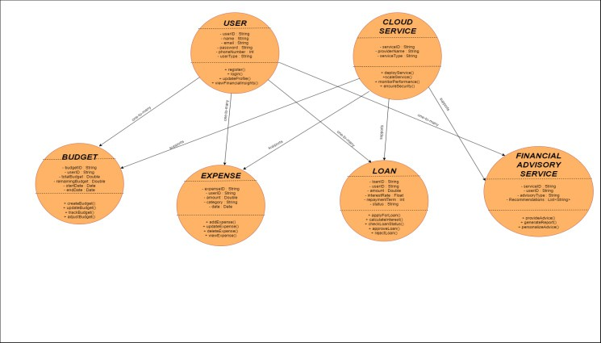

EXPECTED OUTCOMES

✔ Increased Access to Capital: Facilitate easier micro-lending options for users.

✔ Improved Financial Literacy: Equip users with tools for better financial management.

✔ Enhanced Decision-Making: Provide data-driven insights to foster informed choices.

✔ User Engagement: Create a robust platform that encourages consistent usage and growth among entrepreneurs